Types of Roots
# Source: AI Source: Provided by: [Data Path: Persons Table -> ID Column: 1, Name_En Column: Motasem Essam] -> From: [Chatgpt (GPT-4-turbo)] on [7/29/2025]
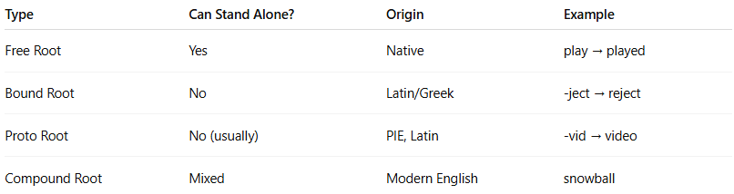

Type | Can Stand Alone? | Origin | Example
Free Root | Yes | Native | play → played
Bound Root | No | Latin/Greek | -ject → reject
Proto Root | No (usually) | PIE, Latin | -vid → video
Compound Root | Mixed | Modern English | snowball

